Continual Self-Supervised Pretraining for Industrial Anomaly Localization

Rafay Saif VR546150 Umar AzizVR536537
MSc Artificial Intelligence, University of Verona, Italy
{rafay.saif, umar.aziz}@studenti.univr.it

Abstract
Industrial anomaly detection is a critical quality-control task in which a system must identify and localize surface defects using only defect-free training images, since real manufacturing defects are rare and expensive to annotate. Despite the dominance of ImageNet-pretrained backbones in this domain, two fundamental questions remain open: whether self-supervised pretraining (SSL) on small, unlabeled, in-domain datasets can produce more discriminative representations, and whether the resulting backbone can be updated sequentially as new product types arrive without forgetting earlier categories. This paper addresses both questions on the MVTec AD benchmark [1] across three product categories (Bottle, Cable, Leather) using a PyTorch implementation combining SimCLR [3] contrastive pretraining with PatchCore [2] anomaly scoring. In Phase 1, we show that SimCLR at 300 epochs outperforms random initialization on all three categories but 100 epochs is insufficient, identifying training budget rather than dataset size as the binding constraint. In Phase 2, we evaluate four continual learning strategies on a sequential Bottle→Cable→Leather task stream: naive fine-tuning (BWT=−0.063), Elastic Weight Consolidation (EWC, BWT=−0.039), Coreset Experience Replay (BWT=−0.011), and PackNet (BWT=−0.073). Coreset Replay reduces catastrophic forgetting by 83%, while PackNet underperforms the naive baseline due to capacity starvation. A per-defect-type analysis further reveals a structural limitation of patch-based local detection for absence-type anomalies, independent of pretraining strategy. Code is publicly available at: https://github.com/rafay-840/Continual-Self-Supervised-Pretraining-for-Industrial-Anomaly-Localization

1. Introduction
Visual inspection in industrial manufacturing is among the most economically significant quality-assurance tasks in modern production systems. Anomaly detection — the problem of identifying deviations from normal appearance at both the image level (is this product defective?) and the pixel level (where exactly is the defect?) — must operate under a severe data constraint: only defect-free images are available during training, since defects on real production lines are rare, heterogeneous, and prohibitively expensive to annotate at scale. A single production line may encounter dozens of distinct defect morphologies over its operational lifetime, each appearing in only a handful of examples per year.
The practical significance of automated anomaly detection is substantial. In the automotive sector, undetected surface defects on structural components can lead to safety-critical failures. In pharmaceutical packaging, contamination or seal defects may render products unsafe. In electronics manufacturing, solder joint and circuit board defects at the sub-millimeter scale escape human inspection under fatigue conditions. The global machine vision market, driven primarily by automated inspection, was valued at over USD 14 billion in 2023 and is projected to grow at a compound annual rate exceeding 7% through 2030.
The MVTec Anomaly Detection benchmark [1] has become the standard evaluation environment for this task, providing 15 product categories with pixel-precise defect masks across multiple defect types per category. The dominant approach on this benchmark is PatchCore [2], which extracts multi-scale feature maps from a frozen pretrained backbone, constructs a compact coreset memory bank of normal patch features via greedy subsampling, and scores test images by nearest-neighbor distance in feature space. PatchCore achieves over 99% image-level AUROC using a WideResNet-50 backbone pretrained on ImageNet — but the backbone is always fixed and always ImageNet-pretrained.
Two important gaps exist in this paradigm. First, ImageNet pretraining transfers features learned from semantically diverse natural images, whose statistics differ substantially from industrial imagery. It is therefore plausible that self-supervised pretraining on the small, unlabeled sets of defect-free images available per MVTec category could yield more discriminative representations for local patch-level anomaly detection. Second, real industrial deployments are not static: new product types are regularly introduced, and retraining the detection system from scratch each time is computationally prohibitive. This motivates a continual learning regime in which the shared feature backbone is updated incrementally without degrading performance on previously-learned product types.
Prior work on SSL for anomaly detection (CutPaste, PANDA, and related methods) has primarily operated on large-scale datasets where SSL benefits are well-established. The regime of very small per-category datasets (~200 images), characteristic of MVTec, has received less attention. Furthermore, catastrophic forgetting in the contrastive feature learning setting underlying embedding-based anomaly detection has not previously been studied. This paper addresses both gaps.
The main contributions of this work are as follows:
• A systematic, controlled evaluation of four backbone initialization strategies — Scratch, ImageNet, SimCLR-100ep, and SimCLR-300ep — under a fixed PatchCore evaluation protocol on three MVTec categories, demonstrating that in-domain SimCLR pretraining requires at least 300 epochs to outperform random initialization, and that training budget rather than dataset size is the primary limiting factor.
• The first continual learning benchmark for PatchCore-based anomaly detection, comparing Naive fine-tuning, EWC, Coreset Replay, and PackNet on a three-category sequential task stream and evaluating catastrophic forgetting via Backward Transfer (BWT).
• A per-defect-type analysis of Cable identifying a structural limitation of local patch-based detection for absence-type anomalies (missing wires, missing cables) that is independent of pretraining strategy and persists across all evaluated methods.
• Category-aware augmentation adaptations for industrial SSL pretraining — including hue-jitter disabling and reduced crop scale for texture categories — shown to be critical for SimCLR performance on industrial datasets.

2. Related Work

2.1. Unsupervised Anomaly Detection
Unsupervised anomaly detection methods broadly divide into three families. Reconstruction-based methods (autoencoders, VAEs, diffusion models) assume that a model trained on normal images will reconstruct anomalous regions poorly [ref]. Flow-based methods learn the distribution of normal feature vectors in a normalizing-flow latent space and flag low-likelihood observations [ref]. Embedding-based methods — the family this paper belongs to — extract features from pretrained networks and measure deviation from the normal feature distribution at test time.
Within embedding-based methods, SPADE [ref] and PaDiM [ref] pioneered the use of pretrained CNN features for both image-level and pixel-level scoring. PatchCore [2] significantly advanced this paradigm by operating directly on intermediate patch-level feature maps, storing a memory-efficient coreset via greedy farthest-point subsampling, and using FAISS-accelerated nearest-neighbor search for fast inference. On MVTec AD, PatchCore achieves state-of-the-art performance across both AUROC and Per-Region Overlap (PRO) [7] metrics. The PRO metric, introduced by Bergmann et al. [7], corrects for the large-region bias present in pixel-level AUROC by computing the fraction of each connected anomalous region covered by the predicted anomaly map, averaging uniformly across regions regardless of their size.

2.2. Self-Supervised Learning for Representation
Contrastive self-supervised learning has produced representations competitive with supervised ImageNet pretraining on standard benchmarks. SimCLR [3] demonstrated that maximizing agreement between differently augmented views of the same image via the NT-Xent loss, combined with a nonlinear projection head and large batch sizes, yields highly transferable visual representations. MoCo [ref] and BYOL [ref] extended contrastive approaches in different directions, but SimCLR remains the most widely studied baseline. SSL applied specifically to anomaly detection has been explored via CutPaste [ref], which uses patch-pasting augmentations as a surrogate task, and PANDA [ref], which applies SSL pretraining followed by nearest-neighbor scoring. However, these methods operate on datasets of tens of thousands of images; the regime of ~200 images per category characteristic of MVTec has not been studied.

2.3. Continual Learning
Continual learning addresses the problem of sequentially learning multiple tasks without catastrophically forgetting earlier ones. The three main families of approaches are: regularization-based methods, which constrain weight changes using importance measures; replay-based methods, which rehearse previous data; and architectural methods, which allocate disjoint parameter subsets per task. EWC [4] penalizes changes to parameters identified as important for earlier tasks via the Fisher information diagonal, protecting critical weights without storing any previous-task data. Experience Replay [5] maintains a buffer of earlier-task examples and mixes them into future training batches, directly rehearsing forgotten data. PackNet [6] permanently freezes task-specific weight subsets via iterative magnitude pruning, providing hard forgetting guarantees at the cost of reduced capacity for later tasks. Progressive Neural Networks [ref] grow entirely new capacity for each task but become impractical at large scale. To our knowledge, none of these approaches has been evaluated for the contrastive representation learning setting underlying PatchCore-based anomaly detection.

3. Method

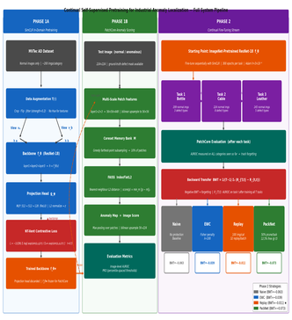
Figure 1. Full pipeline overview. Phase 1A (left): SimCLR in-domain pretraining on normal images per category. Phase 1B (center): PatchCore memory bank construction and anomaly scoring. Phase 2 (right): Continual fine-tuning task stream with Naive, EWC, Replay, and PackNet strategies.

3.1. Problem Formulation
Let C = {c₁, c₂, ..., c_n} be a set of product categories arriving sequentially. For each category c_k, a training set X_k = {x₁, ..., x_m} contains only defect-free (normal) images. At test time, both normal and anomalous images are presented; the system must produce an image-level anomaly score s ∈ ℝ and a pixel-level anomaly map M ∈ ℝ^{H×W}. The continual learning constraint requires that after training on c_k, the system must retain anomaly detection capability on all previously learned categories c₁, ..., c_{k−1}.

3.2. Phase 1: SimCLR In-Domain Pretraining
Given the normal training set X_k for category c_k, SimCLR [3] fine-tunes a ResNet-18 backbone f_θ using contrastive learning. For each image x ∈ X_k, two stochastic augmented views (v_a, v_b) = T(x), T(x) are produced by an augmentation pipeline T. Both views are passed through f_θ to obtain representations h_a = f_θ(v_a) and h_b = f_θ(v_b), and then through a projection head g_φ to produce normalized projections z_a = g_φ(h_a) and z_b = g_φ(h_b). The NT-Xent loss over a batch of N image pairs is:
ℒ = −1/(2N) Σ_i log[ exp(sim(z_i, z_j)/τ) / Σ_{k≠i} exp(sim(z_i, z_k)/τ) ] (1)
where sim(u, v) = uᵀv / (||u|| ||v||) is cosine similarity and τ = 0.5 is the temperature. The denominator sums over all 2N−1 other samples in the batch, treating both other views of different images and the other augmented view of the same image as negatives. The projection head g_φ is a two-layer MLP (512→512→128 with ReLU) discarded after training; only f_θ is retained for downstream feature extraction.
Industrial augmentation adaptations. Standard SimCLR augmentations designed for natural images require adaptation for industrial inspection. We reduce color jitter strength from 0.8 to 0.2 to avoid suppressing color-deviation defect signals that constitute real anomalies (e.g., stains in leather). For texture categories (Leather), hue jitter is disabled entirely, since hue shift can itself be a defect signal. Random crop minimum scale is reduced from 0.5 to 0.2 for texture categories: at scale 0.5, two crops of a near-stationary texture still capture statistically similar global patch statistics, producing weak contrastive signal; at scale 0.2, crops capture genuinely local grain structure, making the contrastive task harder and more informative. RandomGrayscale is omitted entirely since color carries anomaly-relevant information in all three categories.

3.3. Phase 1: PatchCore Anomaly Scoring
Following pretraining, f_θ is frozen and used for feature extraction. We extract and concatenate layer1+layer2+layer3 ResNet-18 activations, producing a 56×56×448 multi-scale feature tensor (layers 2 and 3 are bilinearly upsampled to layer1's 56×56 spatial resolution). This extends PatchCore's original 28×28 resolution from layer2+layer3 alone, improving localization of thin and curved defects such as bottle cracks. The memory bank is subsampled to 10% via greedy farthest-point coreset selection, which iteratively adds the patch feature vector farthest from all currently-selected points — a 2-approximation to the optimal k-center covering problem that preferentially retains rare normal-appearance modes that random subsampling would miss.
At test time, FAISS IndexFlatL2 computes exact nearest-neighbor distances from each test patch feature to the memory bank. The image-level anomaly score is the maximum patch-level distance (max-aggregation). The full 224×224 anomaly map is produced by bilinear upsampling of the 56×56 patch-distance map. A critical implementation detail: PRO thresholds are spaced by percentile of the score distribution rather than linearly over the raw range, since unnormalized FAISS L2 distances can have outlier-scale values that collapse linear-threshold PRO estimates to near zero even when localization is visually correct.

3.4. Phase 2: Continual Learning Strategies
Phase 2 begins from the ImageNet-pretrained ResNet-18 and fine-tunes it sequentially across the task stream Bottle → Cable → Leather using 300 epochs of SimCLR per task. After each task, PatchCore AUROC is evaluated on all categories seen so far. The primary evaluation metric is Backward Transfer (BWT):
BWT = 1/(T−1) Σ_{t=1}^{T−1} (R_{T,t} − R_{t,t}) (2)
where R_{T,t} is AUROC on task t after training through all T tasks, and R_{t,t} is AUROC on task t immediately after it was learned. Negative BWT indicates forgetting.
Naive fine-tuning applies no forgetting-prevention mechanism and establishes the baseline forgetting level. EWC [4] adds a Fisher-weighted regularization penalty to NT-Xent:
ℒ_total = ℒ_{NT-Xent} + (λ/2) Σ_i F_i(θ_i − θ*_i)^2 (3)
where θ*_i are the optimal parameters for completed tasks, F_i is the Fisher information diagonal element approximated from NT-Xent gradients over 20 training batches (λ = 100). Computing Fisher from a contrastive rather than a classification loss is non-standard: F_i here quantifies how much each backbone parameter contributes to separating image pairs in projection space, rather than to class log-likelihoods. Coreset Replay maintains a randomly-selected 100-image buffer per completed category and concatenates 32 replay images uniformly sampled from all previous buffers into each fine-tuning batch before computing NT-Xent, treating replay images as additional hard negatives for current-task views. PackNet freezes 50% of each layer's currently-free weights by magnitude after completing each task, leaving 12.5% of all parameters free for the third task.

3.5. Dataset and Implementation Details
Three MVTec AD [1] categories are used: Bottle (209 normal training images, 3 defect types), Cable (224 images, 8 defect types), and Leather (245 images, 5 defect types). These represent a rigid object, a deformable object, and a surface texture respectively, providing diverse evaluation coverage. All experiments use PyTorch 2.x on a single NVIDIA A100 GPU (Google Colab Pro). Backbone: ResNet-18 with the final fully-connected layer replaced by an identity mapping, yielding 512-dimensional feature vectors. Optimizer: Adam at lr = 3×10^{−4}, batch size 64, drop_last = True (ensuring consistent NT-Xent denominator across batches). Model checkpoints and evaluation results are saved to Google Drive after every completed task to enable disconnection-tolerant resumption, and Phase 1 results are cached as JSON to avoid redundant recomputation across sessions.

4. Results

4.1. Phase 1: Pretraining Strategy Comparison
Tables 1 and 2 report image-level AUROC and Per-Region Overlap (PRO) across all four backbone initialization strategies. Three patterns stand out. First, SimCLR-100ep underperforms random initialization (Scratch) on Cable (0.593 vs. 0.622 AUROC) and Leather (0.827 vs. 0.888), confirming that 100 epochs of contrastive pretraining on ~200 images is insufficient to produce representations more useful than those from a randomly initialized convolutional network under PatchCore's nearest-neighbor scoring. Second, SimCLR-300ep outperforms Scratch on all three categories (Bottle: 0.996, Cable: 0.637, Leather: 0.872), narrowing the gap to ImageNet substantially. Third, ImageNet pretraining remains the strongest individual strategy — expected, given pretraining on 1.28M diverse labeled images — but the SimCLR-300ep gap is small for Bottle (0.004) and moderate for Cable (0.101) and Leather (0.126).

Table 1. Image-level AUROC for all pretraining strategies. Higher is better.
Category | Scratch | ImageNet | SimCLR-100ep | SimCLR-300ep
Bottle | 0.949 | 1.000 | 0.962 | 0.996
Cable | 0.622 | 0.738 | 0.593 | 0.637
Leather | 0.888 | 0.998 | 0.827 | 0.872

Table 2. Per-Region Overlap (PRO) for all pretraining strategies. Higher is better.
Category | Scratch | ImageNet | SimCLR-100ep | SimCLR-300ep
Bottle | 0.703 | 0.896 | 0.668 | 0.778
Cable | 0.518 | 0.826 | 0.597 | 0.632
Leather | 0.780 | 0.907 | 0.701 | 0.728

The PRO results mirror the AUROC pattern but with larger absolute gaps between strategies, indicating pixel-level localization quality is more sensitive to backbone quality than image-level detection. The AUROC/PRO decoupling for SimCLR-100ep on Bottle (higher AUROC than Scratch: 0.962 vs. 0.949, but lower PRO: 0.668 vs. 0.703) suggests that in-domain SSL benefits image-level detection before it benefits pixel-level localization, since the latter requires spatially precise feature discrimination that demands more training epochs to emerge.

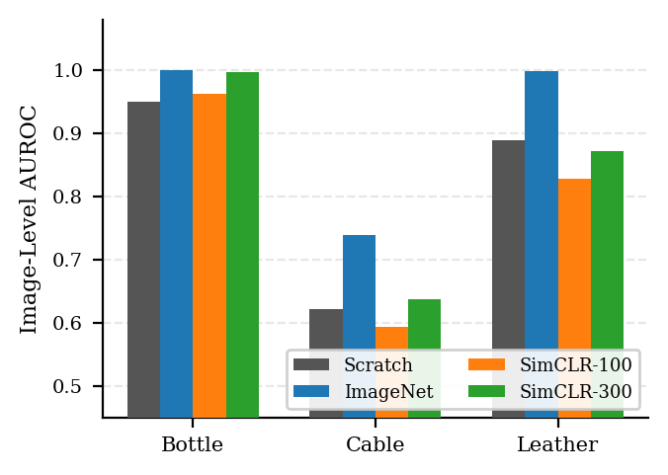
Figure 2. Phase 1 image-level AUROC comparison across all four pretraining strategies on three MVTec AD categories. SimCLR-300ep consistently outperforms Scratch while SimCLR-100ep does not.

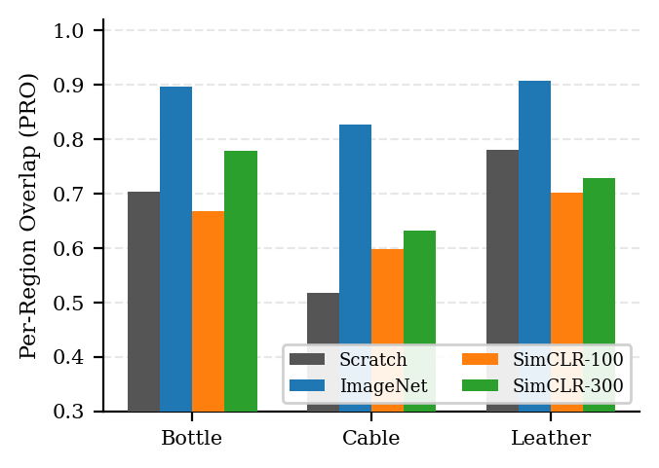
Figure 3. Phase 1 Per-Region Overlap (PRO) comparison. PRO gaps between strategies are larger than AUROC gaps, indicating that pixel-level localization quality is more sensitive to backbone quality.

4.2. Per-Defect-Type Analysis: Cable
Cable's weak AUROC across all strategies motivated a per-defect-type breakdown (Table 3). Defect types with high AUROC (cut_outer_insulation: 0.86, cut_inner_insulation: 0.72) involve local material disruption where a small 4×4 pixel patch looks noticeably different from any normal patch. Defect types with low AUROC (missing_wire: 0.40, missing_cable: 0.42) involve structural absence: a missing wire changes the global spatial arrangement of the cable assembly without necessarily changing the local appearance of any individual patch. This reveals a structural limitation of patch-based nearest-neighbor detection — it cannot detect anomalies defined by what is globally absent rather than what is locally present — that is independent of pretraining strategy and motivates future work incorporating global structural descriptors.

Table 3. Cable per-defect-type AUROC (SimCLR-300ep). Absence-type defects marked †.
Defect Type | AUROC | Category
cut_outer_insulation | 0.860 | Material disruption
cut_inner_insulation | 0.724 | Material disruption
poke_insulation | 0.628 | Material disruption
cable_swap | 0.614 | Configuration
bent_wire | 0.557 | Configuration
combined | 0.538 | Configuration
missing_cable † | 0.417 | Structural absence
missing_wire † | 0.397 | Structural absence

4.3. Phase 2: Continual Learning Results
Table 4 reports BWT and per-category AUROC drop from just-learned to end-of-stream. The naive baseline exhibits strongly asymmetric forgetting: Bottle (AUROC=1.000 at peak) loses only 0.012, while Cable (AUROC=0.755 at peak) loses 0.115. Bottle's perfect peak score leaves little room for degradation; Cable's weaker just-learned score sits closer to the random-guessing decision boundary and is more vulnerable to feature-space drift induced by subsequent fine-tuning on different product categories.

Table 4. Phase 2 BWT and per-category AUROC drop. Less negative BWT = less forgetting.
Strategy | BWT | Bottle Δ | Cable Δ
Naive | -0.063 | -0.012 | -0.115
EWC | -0.039 | -0.006 | -0.071
Replay | -0.011 | 0.000 | -0.021
PackNet | -0.073 | -0.010 | -0.137

EWC reduces forgetting by 40% over naive (BWT: −0.039), with Cable's drop reduced from −0.115 to −0.071. The Fisher-weighted regularization effectively identifies and partially protects the parameters most responsible for Bottle's feature geometry, though accumulated penalties from multiple completed tasks introduce increasing resistance to new learning. Coreset Replay achieves near-zero forgetting (BWT = −0.011): Bottle AUROC remains at 1.000 throughout the entire stream and Cable drops only 0.021. The 100-image buffer represents 40–50% of each category's training set — a high buffer-to-training-set ratio achievable specifically because MVTec categories are small — providing genuine, high-fidelity reminders of earlier-category normal-appearance statistics. Replay images also serve as additional hard negatives within NT-Xent batches, potentially strengthening current-task representations as a secondary benefit.
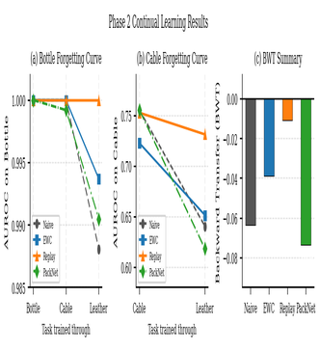
PackNet performs worse than the naive baseline (BWT = −0.073). Two factors explain this. First, capacity starvation: 50% pruning per task leaves only 12.5% of parameters free for the third task (Leather), severely restricting the backbone's ability to learn Leather-specific features, confirmed by Leather's slow loss convergence under PackNet (4.82→4.43 vs. 4.70→2.91 for Bottle without capacity constraints). Second, objective misalignment: magnitude-based pruning selects which parameters to permanently freeze based on their absolute size after NT-Xent training, which does not correspond to their importance for PatchCore's downstream nearest-neighbor anomaly scoring. A parameter that is large in magnitude because it strongly separates two particular normal Cable images in projection space may be less relevant for anomaly detection than a smaller-magnitude parameter encoding fine-grained texture detail. A more conservative pruning ratio (e.g., 30% per task, leaving 34% free for task 3) may substantially improve PackNet's performance and is a direct extension of this work.
Figure 4. Phase 2 continual learning results. (a) Bottle and (b) Cable forgetting curves showing AUROC evolution as each new task is added. (c) BWT comparison across all four strategies. Replay (orange) achieves near-zero forgetting; PackNet (green) degrades below naive.

5. Conclusion
This paper investigated two open questions in industrial anomaly detection: whether self-supervised pretraining on small, in-domain datasets can improve PatchCore-based detection, and whether the resulting backbone can be updated continually without catastrophic forgetting. On the first question, we demonstrated that SimCLR pretraining at 300 epochs outperforms random initialization on all three MVTec AD categories, narrowing the gap to ImageNet pretraining, while 100 epochs is insufficient — establishing training budget as the primary binding constraint for in-domain SSL at small-dataset scales. On the second question, Coreset Replay is the dominant continual learning strategy, reducing backward transfer by 83% relative to naive fine-tuning (BWT: −0.011 vs. −0.063), while PackNet underperforms the naive baseline due to capacity starvation at the 50% per-task pruning ratio.
A per-defect-type analysis of Cable revealed a structural limitation that extends beyond the pretraining-CL axis studied here: patch-based nearest-neighbor detection cannot reliably identify absence-type anomalies (missing components) since these change global spatial arrangement without changing local patch appearance. Future work should address this by incorporating global structural descriptors alongside local patch features. Additional directions include: repeating Phase 2 with a SimCLR-300ep starting backbone to evaluate the pretraining–CL interaction (RQ3, not evaluated here due to compute constraints); testing more conservative PackNet pruning ratios; and extending experiments to the full 15-category MVTec AD benchmark.

6. Individual Contributions
Rafay Saif: project conception and research question formulation (RQ1, RQ2, RQ3); SimCLR pretraining pipeline (Notebook 2) including NT-Xent loss from scratch, category-aware augmentation design, and collapse detection methodology; diagnosis and resolution of Leather augmentation failures across three versions; PatchCore evaluation pipeline (Notebook 3) including multi-scale layer1+layer2+layer3 feature extractor, greedy coreset selection, FAISS nearest-neighbor scoring, and PRO metric implementation; discovery and resolution of the PRO linear-threshold bug via systematic debugging and synthetic unit testing; EWC and PackNet continual learning strategy implementation (Notebook 5); paper writing (Abstract, Introduction, Results analysis, Discussion); coordination of checkpoint naming conventions and Drive directory structure; preparation of GitHub repository and README.
Umar Aziz: MVTec AD data pipeline (Notebook 1) including tarball extraction, MVTecDataset class with train/test splits, defect mask loading, and pixel-level overlay verification; naive continual learning baseline (Notebook 4) including task stream loop, resume/state-file logic for Colab disconnect tolerance, BWT computation, and forgetting curve visualization; Coreset Replay strategy implementation (Notebook 5); execution and monitoring of all Phase 2 continual learning runs including detection and reporting of category-argument mismatch bugs in evaluation cells; per-defect-type AUROC analysis for Cable; paper writing (Related Work, Method, Conclusion, this Contributions section); literature review and reference management.
Both members contributed equally to overall experimental design, result interpretation, and paper revision.

References
[1] P. Bergmann, M. Fauser, D. Sattlegger, C. Steger. "MVTec AD — A Comprehensive Real-World Dataset for Unsupervised Anomaly Detection." CVPR, 2019.
[2] K. Roth, L. Pemula, J. Zepeda, B. Schölkopf, T. Brox, P. Gehler. "Towards Total Recall in Industrial Anomaly Detection." CVPR, 2022.
[3] T. Chen, S. Kornblith, M. Norouzi, G. Hinton. "A Simple Framework for Contrastive Learning of Visual Representations." ICML, 2020.
[4] J. Kirkpatrick, R. Pascanu, N. Rabinowitz, J. Veness et al. "Overcoming Catastrophic Forgetting in Neural Networks." PNAS, 2017.
[5] D. Rolnick, A. Ahuja, J. Schwarz, T. Lillicrap, G. Wayne. "Experience Replay for Continual Learning." NeurIPS, 2019.
[6] A. Mallya, S. Lazebnik. "PackNet: Adding Multiple Tasks to a Single Network by Iterative Pruning." CVPR, 2018.
[7] P. Bergmann, S. Löwe, M. Fauser, D. Sattlegger, C. Steger. "Uninformed Students: Student-Teacher Anomaly Detection with Discriminative Latent Embeddings." CVPR, 2020.

